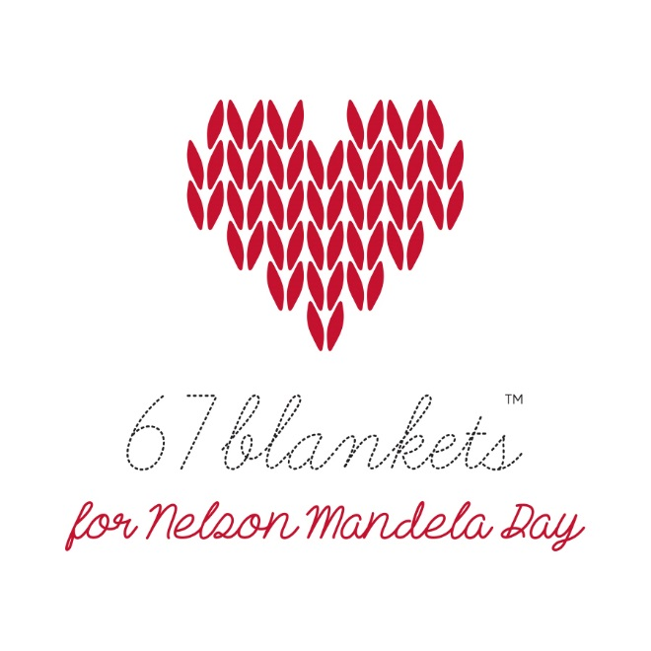
“67 Blankets for Nelson Mandela Day” Blanket Handover Form
- Thank you for supporting our initiative.
- 67 Blankets for Nelson Mandela Day is a registered trademark. No person, organisation or any other entity may use this trademark without the express written permission of the founder, Carolyn Steyn. No items may be distributed under the 67 Blankets banner without being fully processed through our systems by one of our Regional Administrators.
- The information you give us is absolutely safe. We will never rent, sell, share or otherwise disclose your personal information to third parties.
- Secure this form to your blanket. One form for each blanket please. The best way to do this is to put the form into a plastic sleeve, seal the top with tape and cable tie or safety pin to the blanket. This method of securing the form to the blankets should ensure that we will be able to track your blanket through to distribution.
- Once pledged, blankets become the property of 67 Blankets for Nelson Mandela Day.
- All blankets will be distributed to deserving charities by 67 Blankets for Nelson Mandela Day once they have been handed in and processed.
- Distribution of blankets is at the sole discretion of 67 Blankets for Nelson Mandela Day. 67 Blankets for Nelson Mandela Day will identify suitable beneficiaries to receive the blankets. 67 Blankets for Nelson Mandela Day will consider all applications received on a Beneficiary Request Form, but the final decision rests with 67 Blankets for Nelson Mandela Day.
Pledge Reference |  | Size of Blanket Pledged |  | Pledged Date to be handed in by:

Donor Contact Details
First Name |  | Last Name
Mobile Number |  | eMail Address
Suburb where you live |  | City
Do you represent an organisation such as a company, NPO, school, retirement home etc?

If Yes, please provide us with the organisation name and physical address.
Do you belong to a group that meets regularly?

If Yes, please give us the name of the group and/or the name of the group leader.
Comments:

For office use:
Tag Number Assigned to this Blanket
Drop-off Point
Collected By Name
Date Collected

